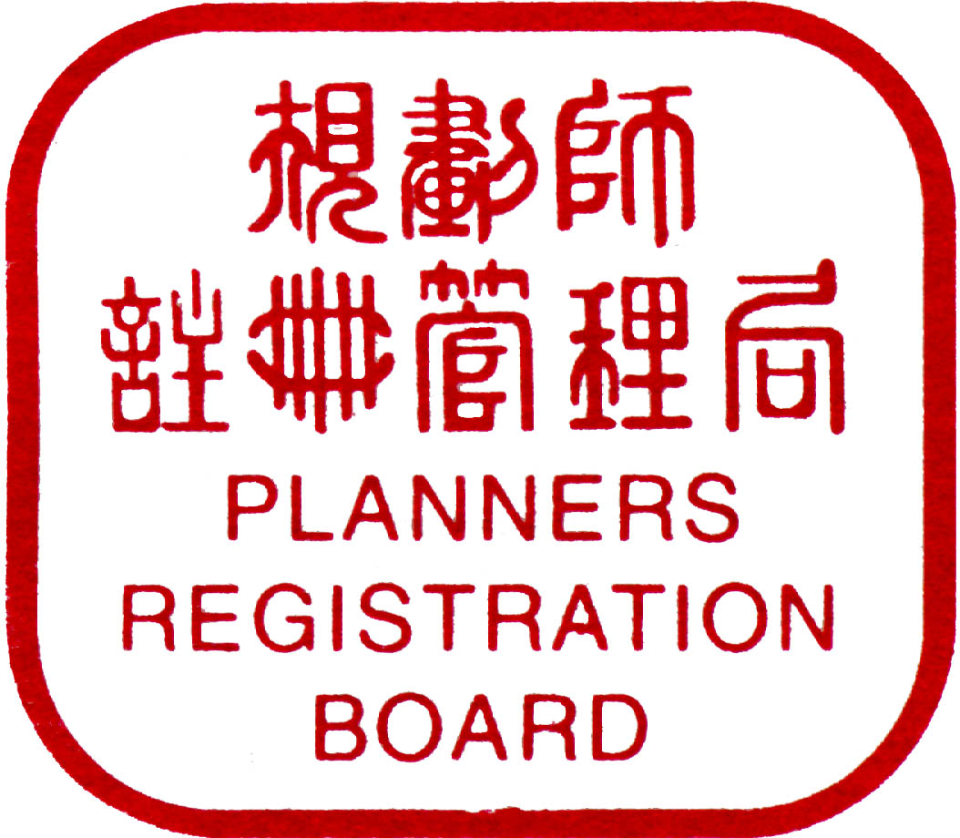
PLANNERS REGISTRATION BOARD
規劃師註冊管理局
香港北角英皇道663號泓富產業千禧廣場2樓201室（電話︰2915 6212）（圖文傳真︰2915 7616）
Unit No. 201, 2/F, Prosperity Millennia Plaza, 663 King’s Road, North Point, Hong Kong (Tel : 2915 6212) (Fax : 2915 7616)

APPLICATION FOR REGISTRATION AS A

REGISTERED PROFESSIONAL PLANNER

To : | The Registrar  Planners Registration Board  Unit No. 201,  2/F, Prosperity Millennia Plaza,  663 King’s Road,  North Point,  Hong Kong |  | Please  affix  recent  photograph  here
1. PERSONAL INFORMATION
Name# : |  |  | (Prof./Dr./Mr./Ms./Mrs./Miss*)______________________________________________  (Surname) (Other Names)
Name in Chinese# (if applicable) : |  |  |  |  |  | ______________________________________________
H.K. Identity Card No./Passport No. * (for identification only) : |  |  |  |  |  |  | _________________________
Date of Birth : |  |  |  |  | ____________________(dd-mm-yy) Sex#: _________________________
Residential Address (Optional):_______________________________________________________
________________________________________________________________________________
Tel.:__________________Fax. _____________________
Name of Business Organization#: ____________________________________________________
Business Address#:________________________________________________________________
________________________________________________________________________________
Tel.#: __________________ Fax. # : _____________________
Correspondence Address (Residential / Business *) : _____________________________________
________________________________________________________________________________
Contact Tel. : ___________________ Fax. : ________________ Email :
Note : |  | (a) |  | Please read carefully the Guidance Notes for Application for Registration as a Registered Professional Planner and the Guidelines for Considering New Applications for Registration before completing this form.
 |  | (b) |  | Please complete this form in BLOCK LETTERS.
 |  | (c) |  | This form must be accompanied by a registration fee (non-refundable) as specified in the Guidance Notes made payable to the Planners Registration Board and certified true copies of all certificates and any other documents stated in sections 2 to 5 below.
2. | ACADEMIC QUALIFICATIONS  (please give details of academic qualification obtained and planning course attended)

Academic Institution – Course |  |  |  | Degree / Diploma Awarded | Award Date
3. | PROFESSIONAL QUALIFICATIONS #  (please give details of professional planning qualification obtained)

Professional Institution |  |  |  | Class of Membership | Membership  Number | Admission Date
4. | PROFESSIONAL EXAMINATION  (please give details of examination passed which is necessary for fulfilment of the Board’s qualification requirement)

Name of Institution | Examination Passed | Date
# Information to be entered into the Register

5 | RELEVANT PROFESSIONAL EXPERIENCE  (please give a brief outline of relevant professional experience in Hong Kong in the following table and provide a detailed account of planning experience in the Statement of Experience (Form SE/01/1))

Name of |  |  |  |  | Period |  |  | Brief Description
Organization |  |  |  | Position Held | From |  | To | of Projects (by categories with period of time) and Duties
6. |  | Periods of absence exceeding 3 months from Hong Kong within the past two years (please give dates).
7. |  | Registered Professional Planner (RPP) as referee (if any) for my application  Name of RPP: RPP No.  Signature:

8. DECLARATION and UNDERTAKING
 | (a) | I have/have not* had over one year relevant professional experience in Hong Kong before the date of this application for registration.
 | (b) | I am/am not* ordinarily resident in Hong Kong.
 | (c) | I have/have not* been the subject of an Inquiry Committee or a disciplinary order under Part IV of the Planners Registration Ordinance.
 | (d) | I have*/have not been convicted of an offence in Hong Kong or elsewhere which may bring the profession into disrepute.
 | (e) | I have*/have not committed misconduct or neglect in a professional respect.
 | (f) | I am/am not* competent to practise as a professional planner.
 | (g) | I declare that all the above information is true.
I attach hereto one certified true copy of each certificate/document, in A4 size, stated in sections 2 to 5 above, the originals of which can be submitted for examination by the Board if required.

I acknowledge that the Board reserves the right to require an applicant to sit for a written examination and/or to clarify or elaborate on the information as contained in the application form and the Statement of Experience.

I acknowledge that I am fully aware of the provisions in the Planners Registration Ordinance 1991, the Guidance Notes for Application for Registration as Registered Professional Planners and the Guidelines for Considering New Applications for Registration.

I consent to the personal data contained herein being used by the Planners Registration Board for all administrative purposes, as described in Guidance Notes for Application for Registration as Registered Professional Planners.

I undertake that I will inform the Registrar, Planners Registration Board in writing within 28 days of any change to the above particulars.

Signature : _____________________________ |  |  | Date : __________________________
(For PRB Use Only)
Application Received on :_____________________Fee Received on :___________________
Professional Qualifications Checked : ___________ Certificates/Documents Checked :____
RC Date :____________________________ Decision :_____________________________
PRB Date :___________________________ Decision :_____________________________
Registration Period :___________________ Applicant Notified :________ RPP No. ___
*Delete as appropriate

PLANNERS REGISTRATION BOARD
規劃師註冊管理局
香港北角英皇道663號泓富產業千禧廣場2樓201室（電話︰2915 6212）（圖文傳真︰2915 7616）
Unit No. 201, 2/F, Prosperity Millennia Plaza, 663 King’s Road, North Point, Hong Kong (Tel : 2915 6212)(Fax : 2915 7616)

Please refer to the Guidance Notes for Application for Registration as a Registered Professional Planners and the Guidelines for Considering New Applications for Registration before completing this Statement

Statement of Experience

Section 1 - Declaration
I, Dr/Mr/Mrs/Ms/Miss hereby certify that the information contained in this form represents a true account of my planning experience up to the time of submission.

Signature Date

Section 2 - Corroboration of Applicant's Experience
I am aware of the Planners Registration Board's Guidelines on qualification and experience required for registration as outlined in Section 3 below and I certify that the description of that part of work which I have countersigned in the Statement of Experience submitted by is to my personal knowledge correct in all particulars.

1. Name Qualifications
Signature Date
Official Position of (Company)

2. Name Qualifications
Signature Date
Official Position of (Company)

3. Name Qualifications
Signature Date
Official Position of (Company)
Note: (a) A Corroborator must have personal knowledge of the applicant's experience, should be in a senior position and preferably, a qualified planning professional though not necessary a Registered Professional Planner
(b) Each Corroborator countersigning the Statement of Experience in the margin provided must also sign in the spaces provided above. Should more than three Corroborators be involved, additional signatures may be attached to the form as a separate sheet.

Section 3 - Statement of Experience

Period Involved | Statement | Signature of Corroborator
(Use additional sheet if necessary)

